**Capstone project**

1. Download the zip file to a folder from Capstone project
2. Unzip the file to a folder
3. Open git bash terminal,navigate to capstone project

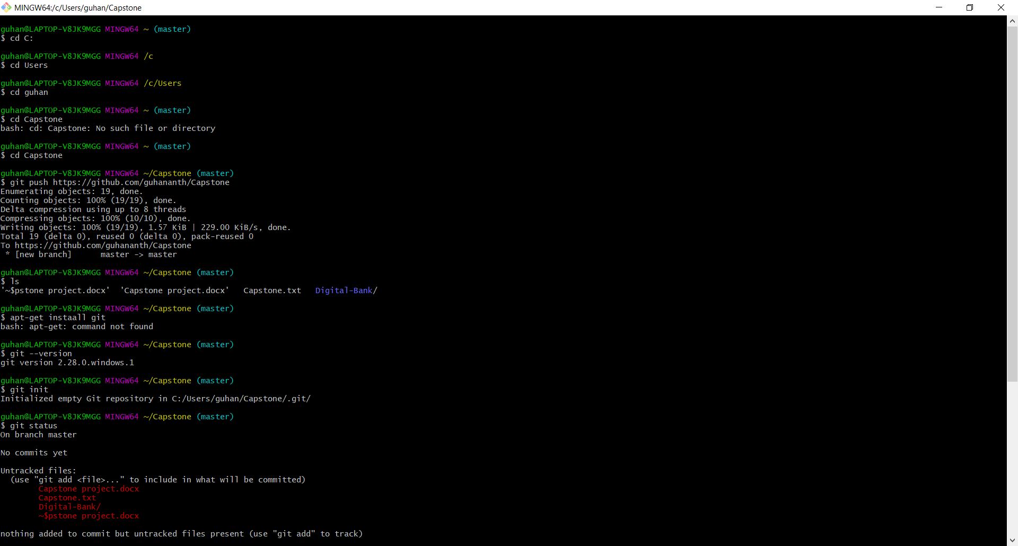

1. Initializ git init.
2. Git init .add
3. $ git commit -m "Adding Capstone files to Capstone repository"
4. Give remote add origin master <https://github.com/guhananth/Capstone.git>

$ git remote add origin https://github.com/guhananth/Capstone.git

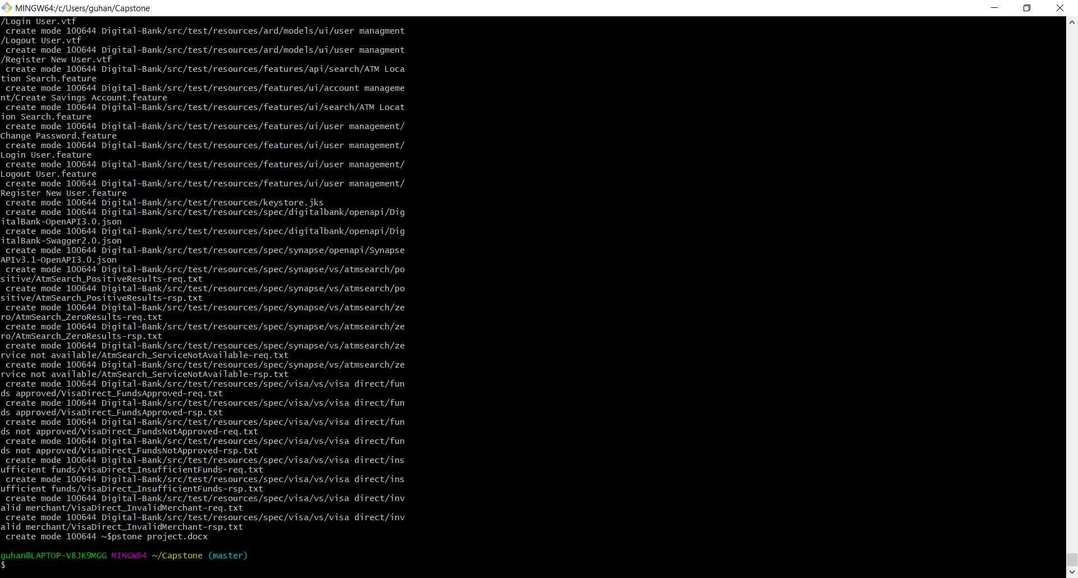

1. push file to repository by giving the command

$ git push -u origin master

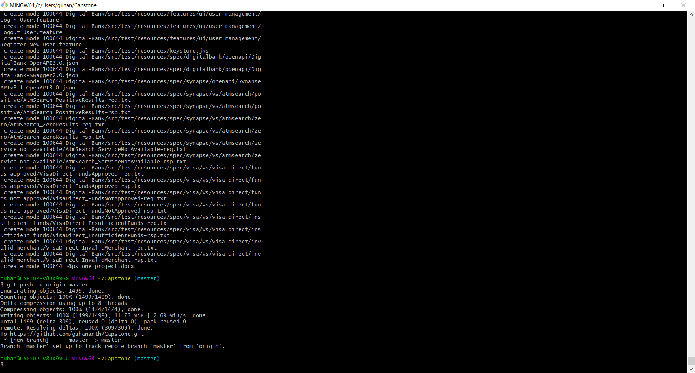

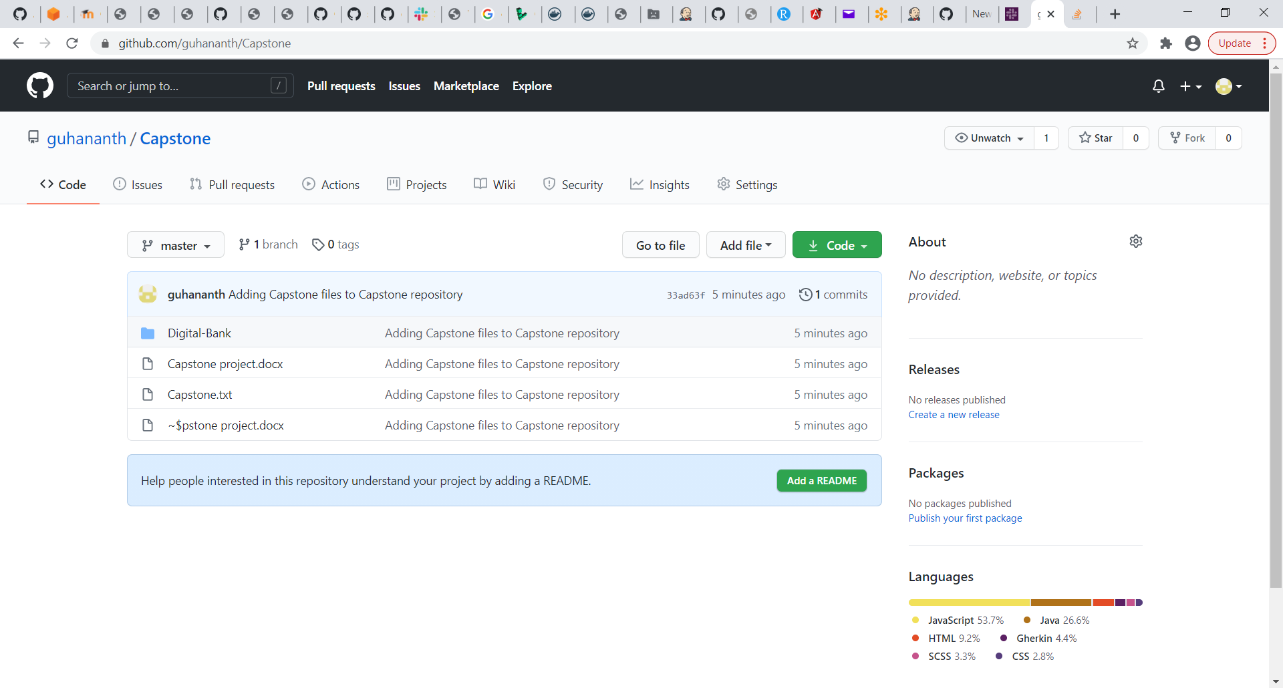

**Set up Jenkins server**

* Configure the Jenkins port in AWS by using T2 large instance

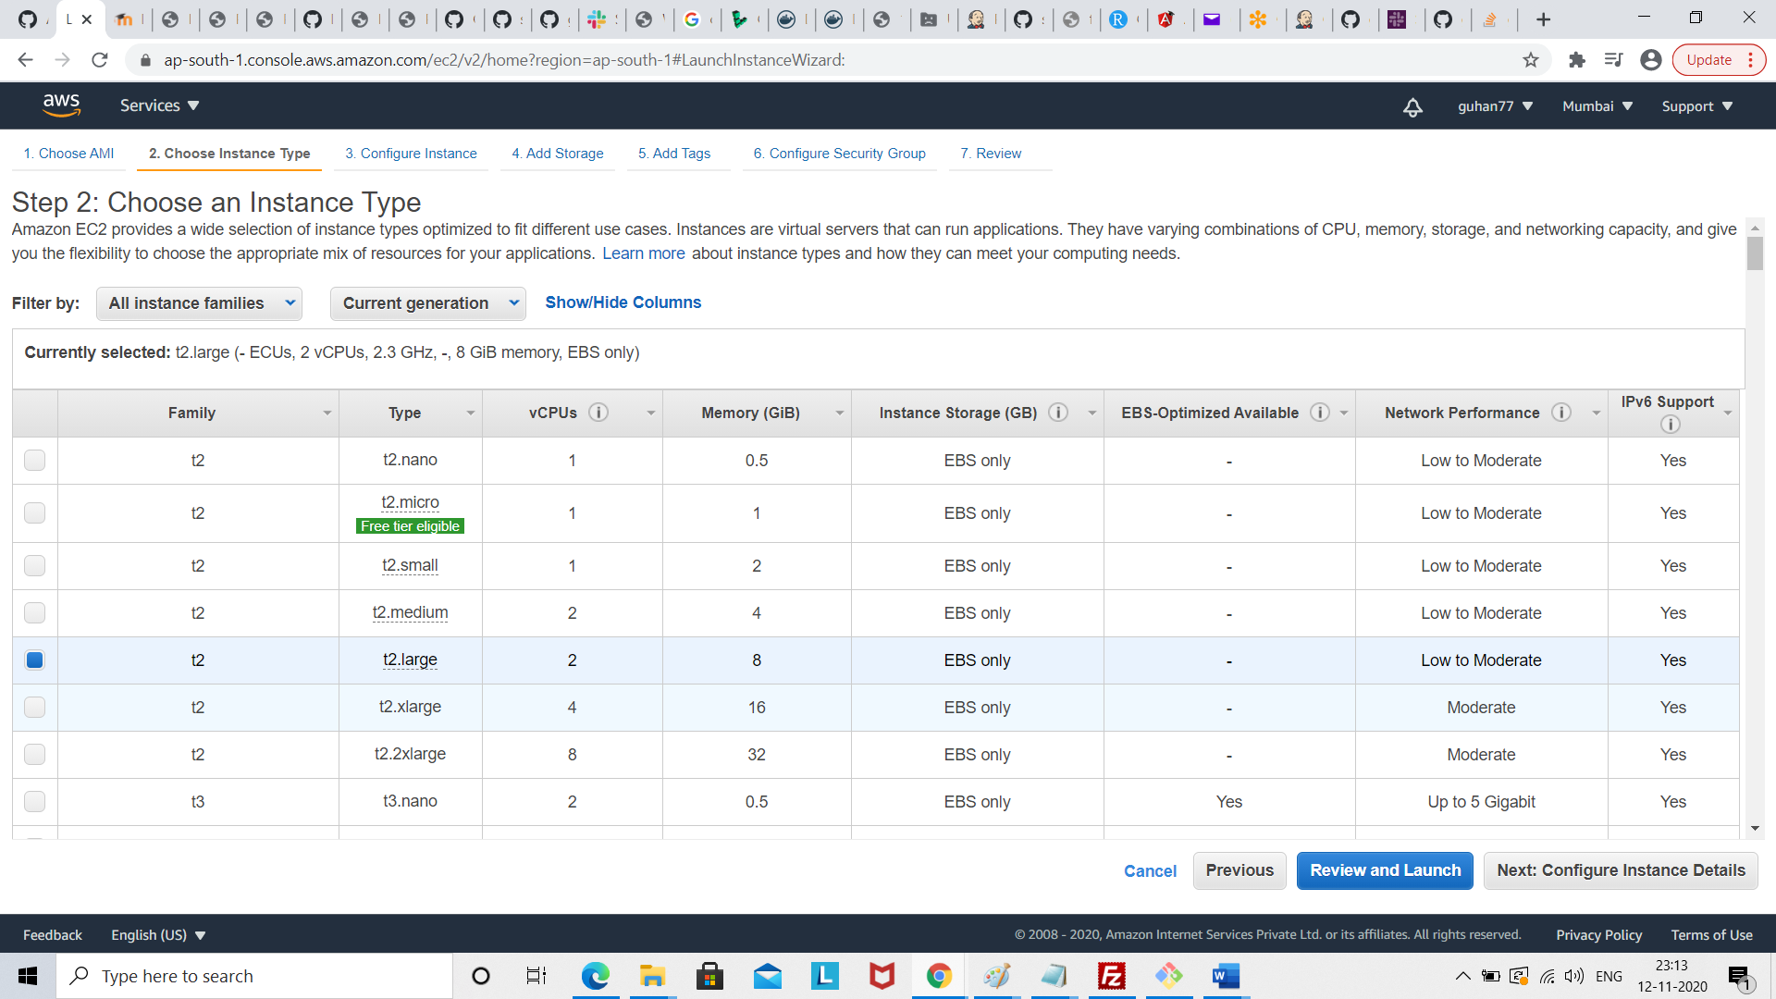

* 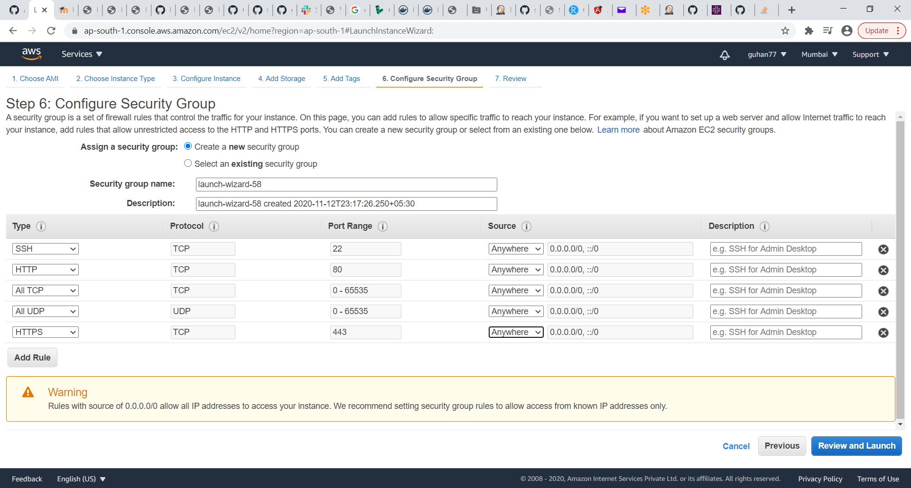
* Review and launch

Run ssh command in git bash

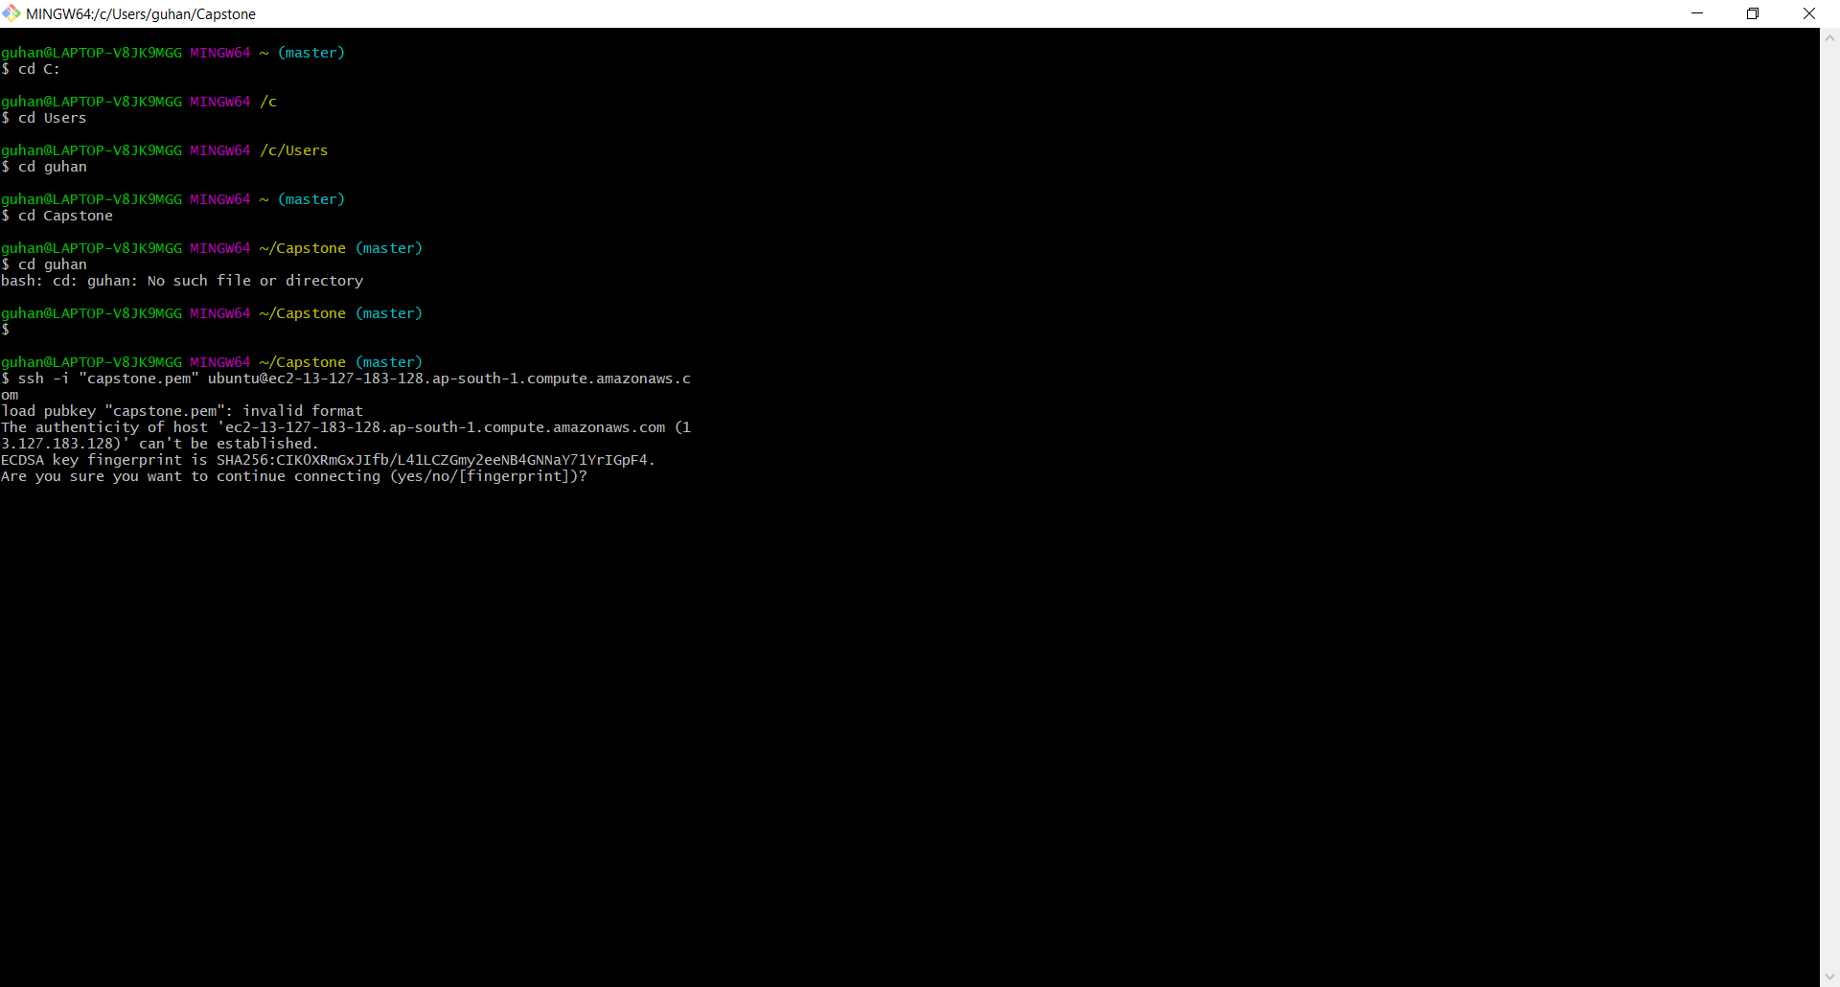

Click yes

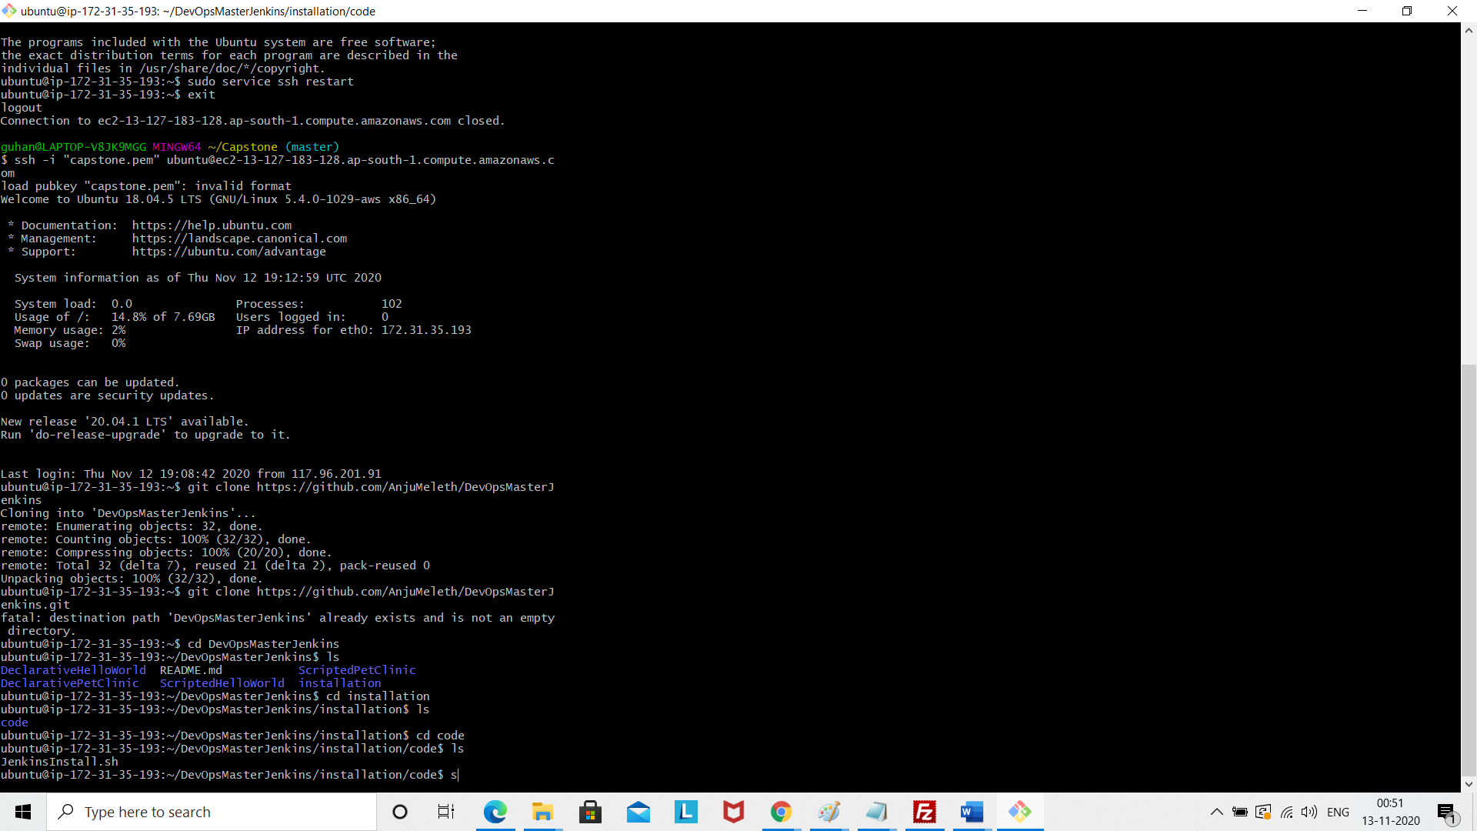

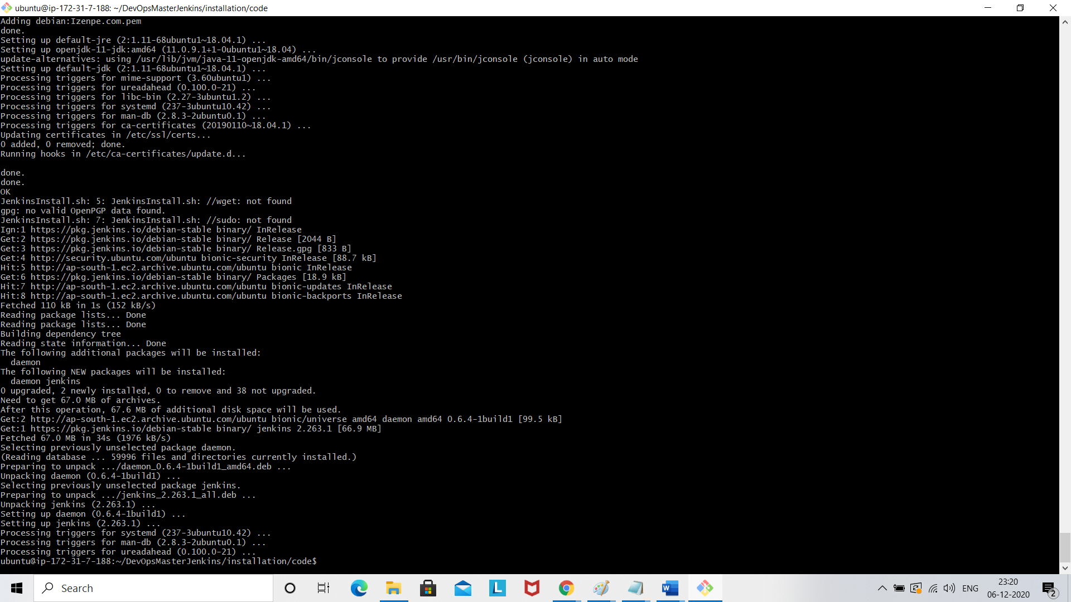

Now access Jenkins url by typing public url of Jenkins

https://65.0.122.137:8080

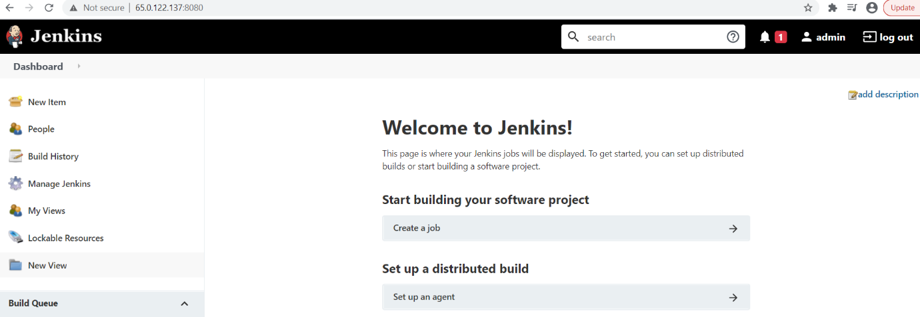

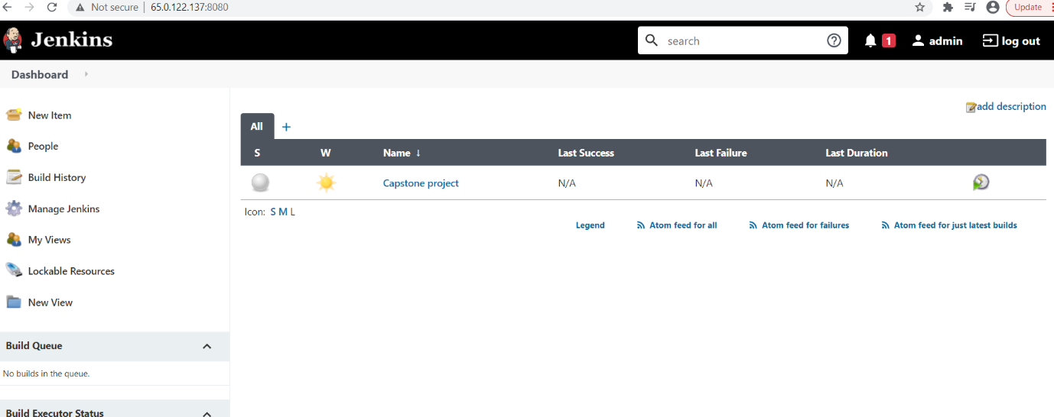

Install maven plugin in Jenkins

